TASK 1 : FOR ALL THE STUDENTS - Introducing ourselves to our partners
Due date : November 25th

- Register and create your own avatar online

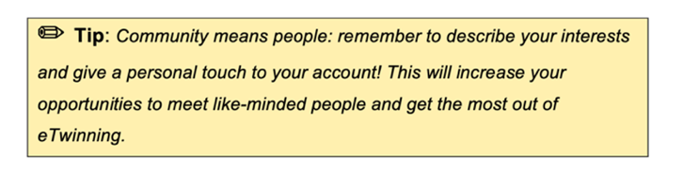
- Edit your profile
Do not leave blank spaces where you can provide information that will help others to learn more about you.
To do this, go to the Desktop and customise your profile with more details and your avatar.
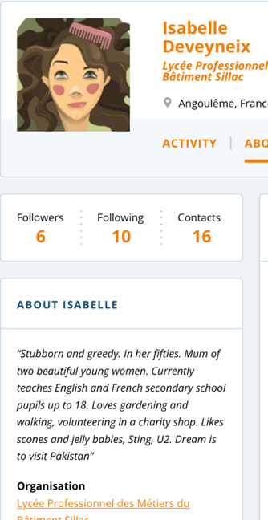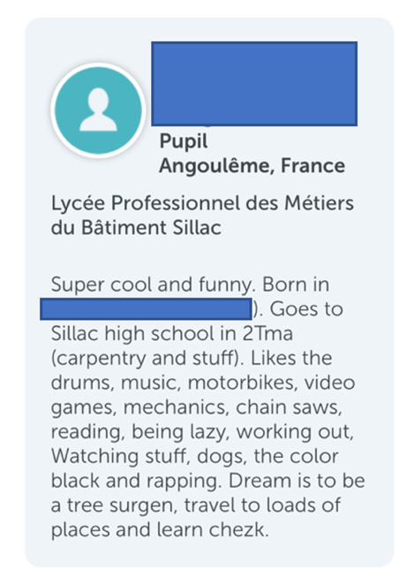

Learn how to write a personal profile for a social app or website.
https://learnenglish.britishcouncil.org/fr/skills/writing/pre-intermediate-a2/a-personal-profile

TASK 1: FOR All THE STUDENTS - Introducing ourselves to our partners
Due date : November 25th

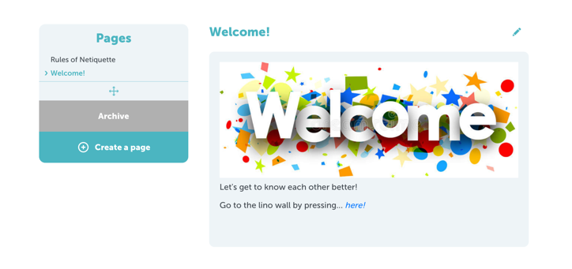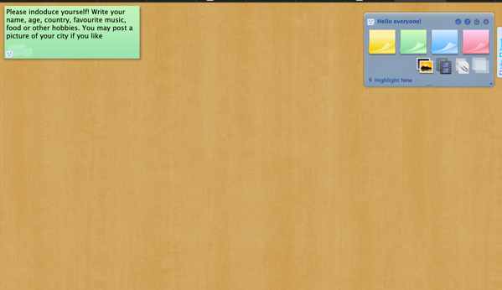

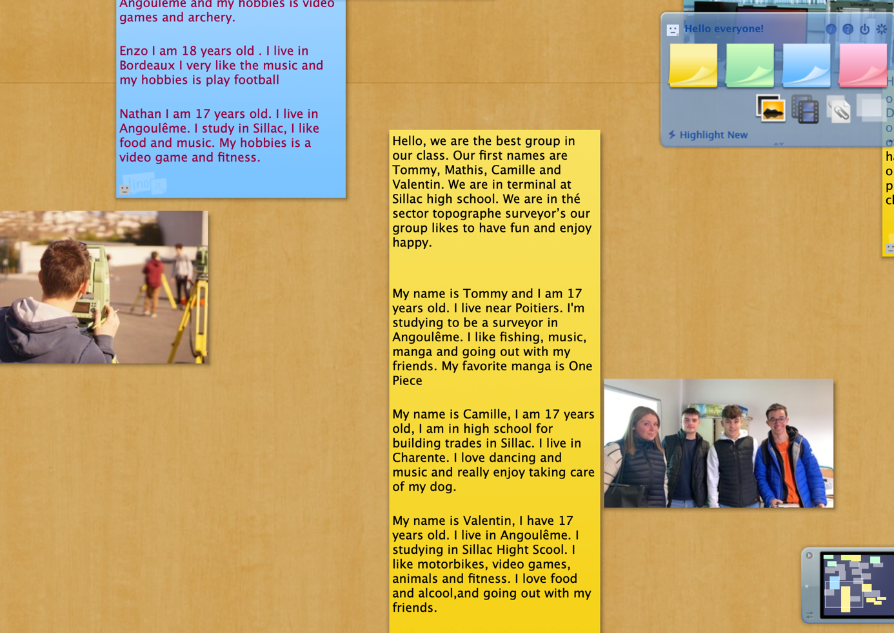

TASK 2 – FOR FRENCH STUDENTS - Presenting our high school
TEAM 1 – Locating our school in France – Using genially, create a slideshow about the Nouvelle Aquitaine
Due date : December 2nd
4 members : Camille, Valentin, Mathys, Tommy

Where we live

TASK 2 – FOR FRENCH STUDENTS - Presenting our high school in a 30-second video
TEAM 2 – present our school in a short video
Due date : December 2nd
4 members : Romain, Enzo ,Baptiste, Nathan

Our school

TASK 5 – FOR FRENCH STUDENTS - Presenting our high school in a 30-second video
TEAM 3 –« what you are taught »
Due date : December 2nd
4 members : Matéo, Bastien, Léo, Axelle

The subjects we learn at school

