eTwinning project : A virtual museum
Introduction :
The project consists in creating / designing a virtual museum on Artsteps to put 3D models
Artsteps is a site which allows you to create free virtual exhibit where you can read information on an individual object

First, we introduced our high school to our partners.
To do so, we created / were divided into three groups ….

Our English teacher told us about Erasmus+ and eTwinning which is a part of Erasmus+. eTwinning is a platform for teachers and school staff to communicate, collaborate and develop projects.
She showed us one of the projects carried out last year which involved 3-D printing.
We agreed to do this project because we can present it in the English exam at the end of the year. It’s also a chance to meet Greek partners.
There were two schools in the project
The first school is ……..
The second one ………..

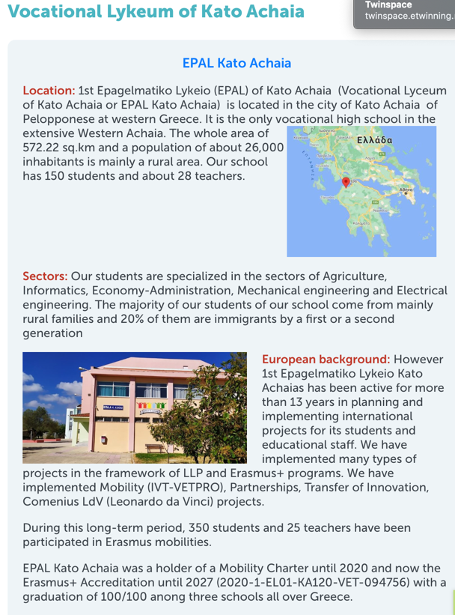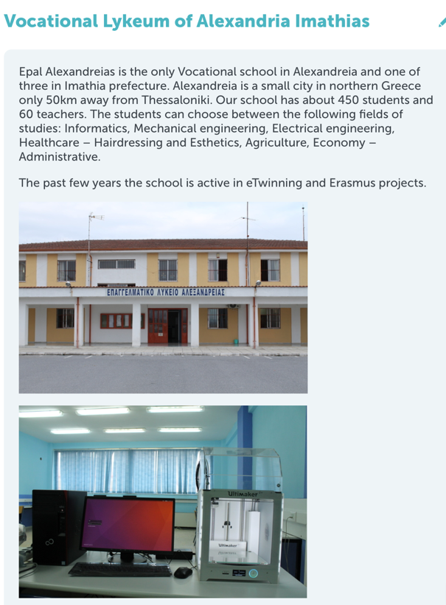

We also watched a video about the netiquette
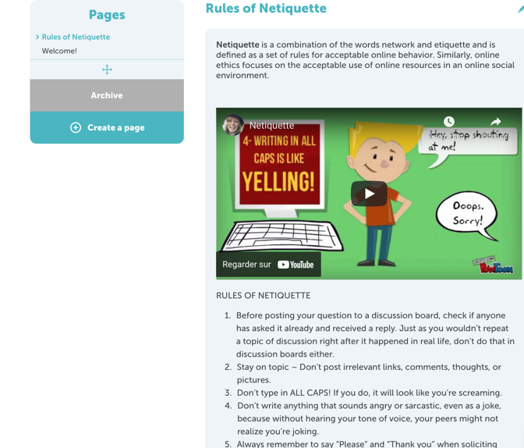
This is what I will remember from this video :

Then we wrote a small text to introduce ourselves and choose a picture. We had great fun

Finally, we drew lots for the team members.
What is the project about ?

