Tonnay Charente : Now and Then !

Before :

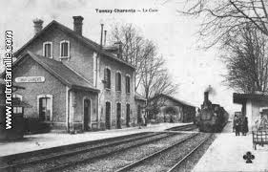

Before, there was a station where all the tonnacquois could wait for their train.
This station was built in 1867 by the company of Charente.
It was located near the city center.

Now :
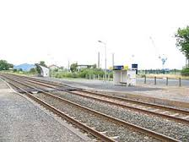

Now, there is not a railway station any more.
So we need to go to the station of Rochefort to take the train.
Now, there are only the train tracks remains.

By Marine and Mélissa-5C

