NELSON ROLIHLAHLA
MANDELA

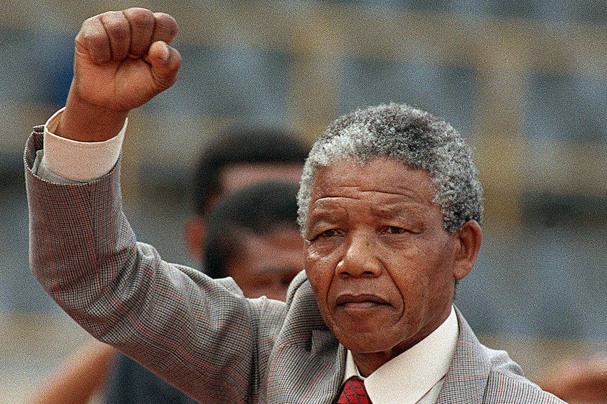
*born in Transkei, South
Africa on July
18th 1918

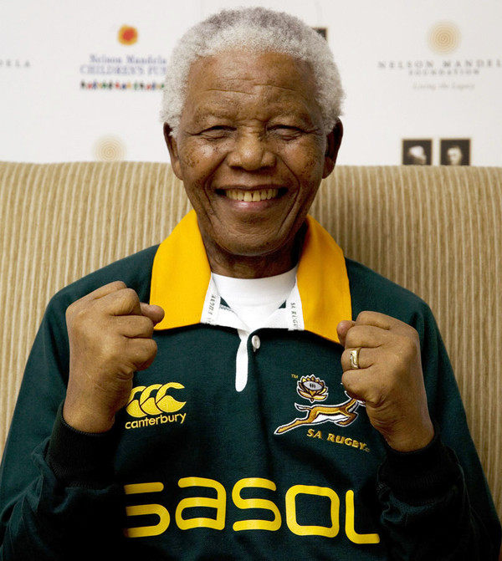
His father was hendry mphakanyiswa
of the tembu tribe mandela himself was
educated at university college of fort here and the university of witwersand where he study law.He joined the African National Congress in 1944and was engaged in resistance against the runing National Party's apartheid policies afther 1948 he went on trial for treason in 1956-1961 and was acquietted in 1961
attention au « copier-coller », respecte les consignes du modèle avec les 3 parties : private life, carrer, what facts to remember

