MY HOUSE

Type of housing :

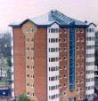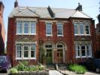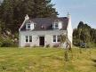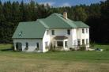

In a block of flats in a semi-detached house In a cottage in a detached house

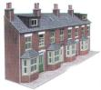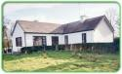

In a terraced house in a bungalow

How many rooms ? THERE ARE ….......................ROOMS

Names of the rooms : write it under each picture



 

