MY FAVOURITE ANIMALS AND PETS YOU TUBE

Activity one : Identify the animals in the document : which ones can you see ? Circle the right answers :
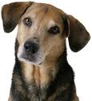
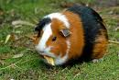
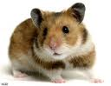
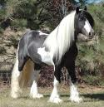
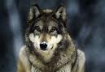
a dog a guinea pig a hamster a horse a wolf
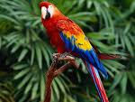
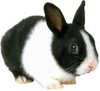
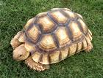
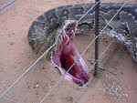
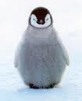
a parrot a rabbit a tortoise a snake a penguin

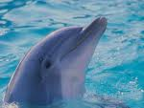
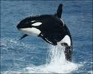
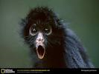
a cat a dolphin an orca a monkey
Activity two : which adjective(s) can describe these animals ?

Funny : _______________________________________________________
beautiful : _____________________________________________________
Elegant : ______________________________________________________
Gentle/soft : ___________________________________________________
helpful : _______________________________________________________
loyal : _________________________________________________________
friendly : ______________________________________________________
intelligent/clever : _______________________________________________
dangerous : ____________________________________________________

homework : learn your words

fill in : In my opinion....
According to me the cutest is the ___________________________, the funniest is the __________________________and the most intelligent is the ______________________________

