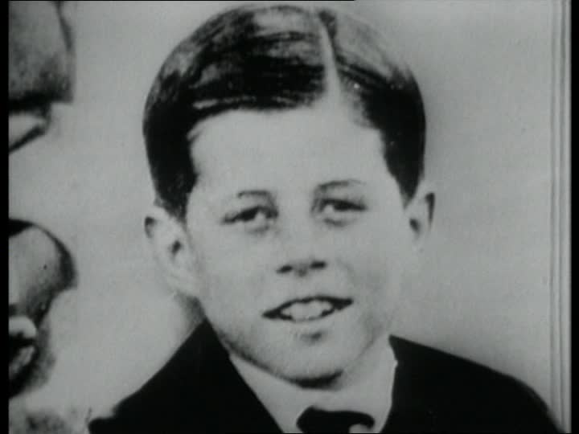
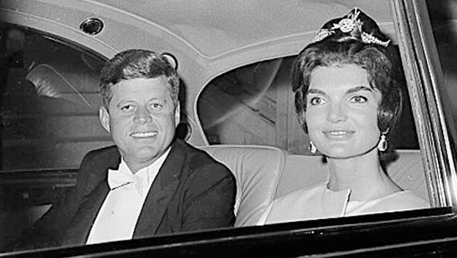
John Fitzgenald Kennedy
(1917-1963)
Private life:
* born on May 29th 1917 at Brookline.
* the second in a family with nine children.
*His parents,Joseph Patrick Kennedy who made a fortune in the 1930s and Rose Fitzgerald.
*Studied at Princeton and after at Harvard.
* On 12 Septembre 1953 : married Jacqueline Bouvier in ST Mary's Church in Newport
* two children.

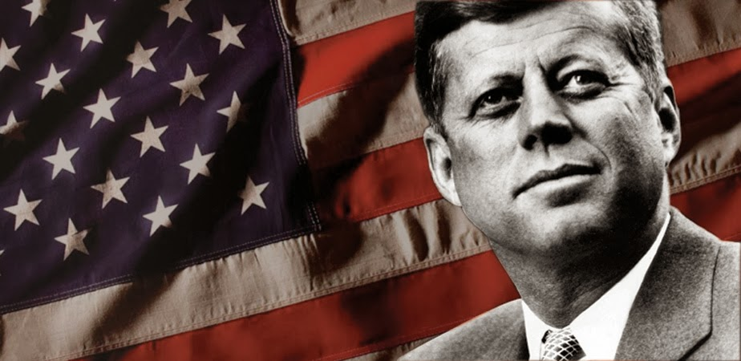
President life:
*Became senator of Massachusetts.
*Was elected President
*1961 Kennedy faced the Berlin crisis.
*Was shot dead
*Died on 22 November 1963 in Dallas.
*he has fought against racism
*he lauched the apollo programe

