THE SHOPPING PAGE !
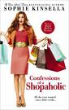
What did you buy ?

I bought …..write the price on the tag !
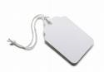
cds dvds clothes books
tea toffees/chocolates souvenirs
postcards shoes plushes

HELP !
BRITISH CURRENCY : THE BRITISH POUND
Banknotes Coins
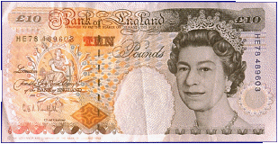 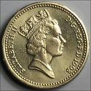 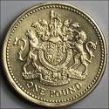one pound £1
10 pound £10
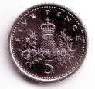 5 pence

