FIRST DINNER WITH MY FAMILY

WHAT DID YOU EAT ? CIRCLE IT !

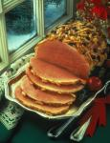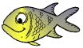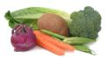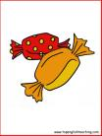

Meat fish vegetables sweets

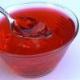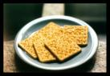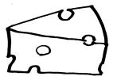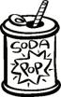

Ice-cream jelly crackers cheese soda

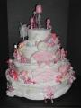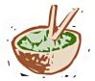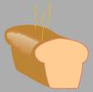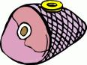

Cake salad bread ham

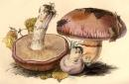

Mushrooms sausages

