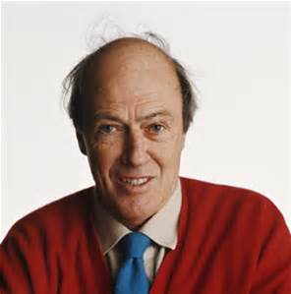
Roald Dahl

He was bornon september 13 1916 in Liandaff.
He died there on november 23,1990,at the age of 74

He composed 19 children s boo

Personal life

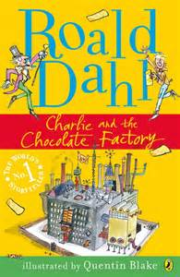
He married film actresse Patriçia Neal and resultted in five children.

The couple divorced in 1983.

The rest

He wrote charlie and the chocolade factory.
He jointed the royal air force.

