COLUCHE
28 October 1944-19 June 1986
French actor, humorist, politician
PRIVATE LIFE
- born in Paris

- real name is Michel Colucci

- married Veronique K. Colucci on 16 October 1975 and divorced in 1981

- 2 children

- loved speed, especially motorcycles

-died in a motorcycle
accident in Opio, Alpes-maritimes

CAREER

- acted in « L’aile ou la cuisse » in 1976,
« Inspecteur la Bavure » in 1980 and
« Tchao pantin » in 1983

- started his fist one-man-show in 1973
« Mes adieux au music hall »

- in 1974, he made his first solo show

Which film and action to remember?

-founded the French charity association
« Les Restos du Coeur »

- candidate for the presidence of French Republic in 1981

- in 1968 he met Romain Bouteille with whom he founded the « Café de la Gare »

- acted a lot of comedies
THE quote

« Dieu a dit :
- Je partage en deux. Les riches auront de la nourriture, et les pauvres auront de l’appétit. »

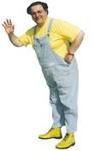

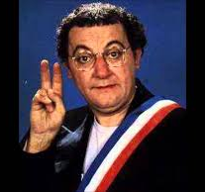

CLOTHES
Glasses, blue and
white striped
overalls, yellow
t-shirt and
yellow boots
( on stage for
his one-man
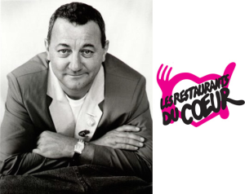
shows)

