ANDY WARHOL

6 august 1928 – 22 February 1987
American painter and filmmaker
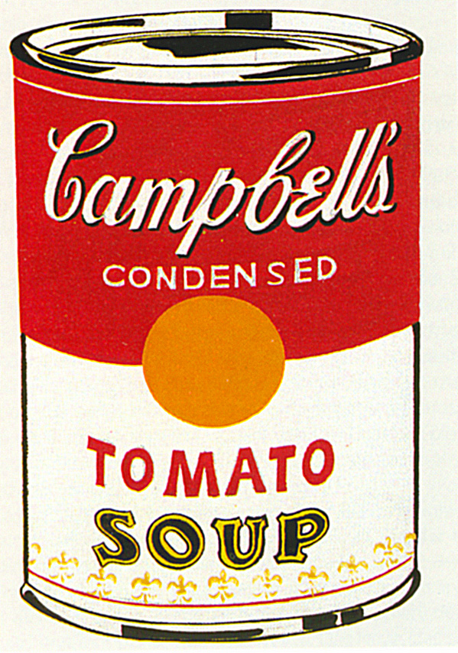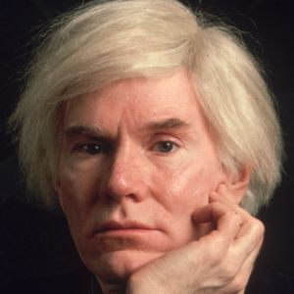
Childhood :
*Born in Oakland Pittsburgh Pennsylvania.
*His father died when he was 14
*two brothers. (Paul and John)

Career :
Debuted the concept of pop art in 1961.
Exhibited the “now-iconic” paintings of Campbell’s soup cans in 1962
Painted celebrity portraits included Marilyn Monroe, Mick Jagger…
Opened his own art studio in 1964

What to remember?
* Painted Marilyn Monroe , Mickael Jackson…
* But also the “ Green Coca Cola Bottles “
*1969 : Warhol published the first copies of its magazine.
* 1980 : Warhol produced videos clips.



